**Yashoda Girls’  
 Arts & Commerce College, Nagpur**

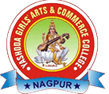

**Department of Urdu**

**Continuous Internal Evaluation**

**B.A Part l, ll, lll - Even Semester**

**Academic Session: 2024-25**

**BA PART-l Semester-ll**

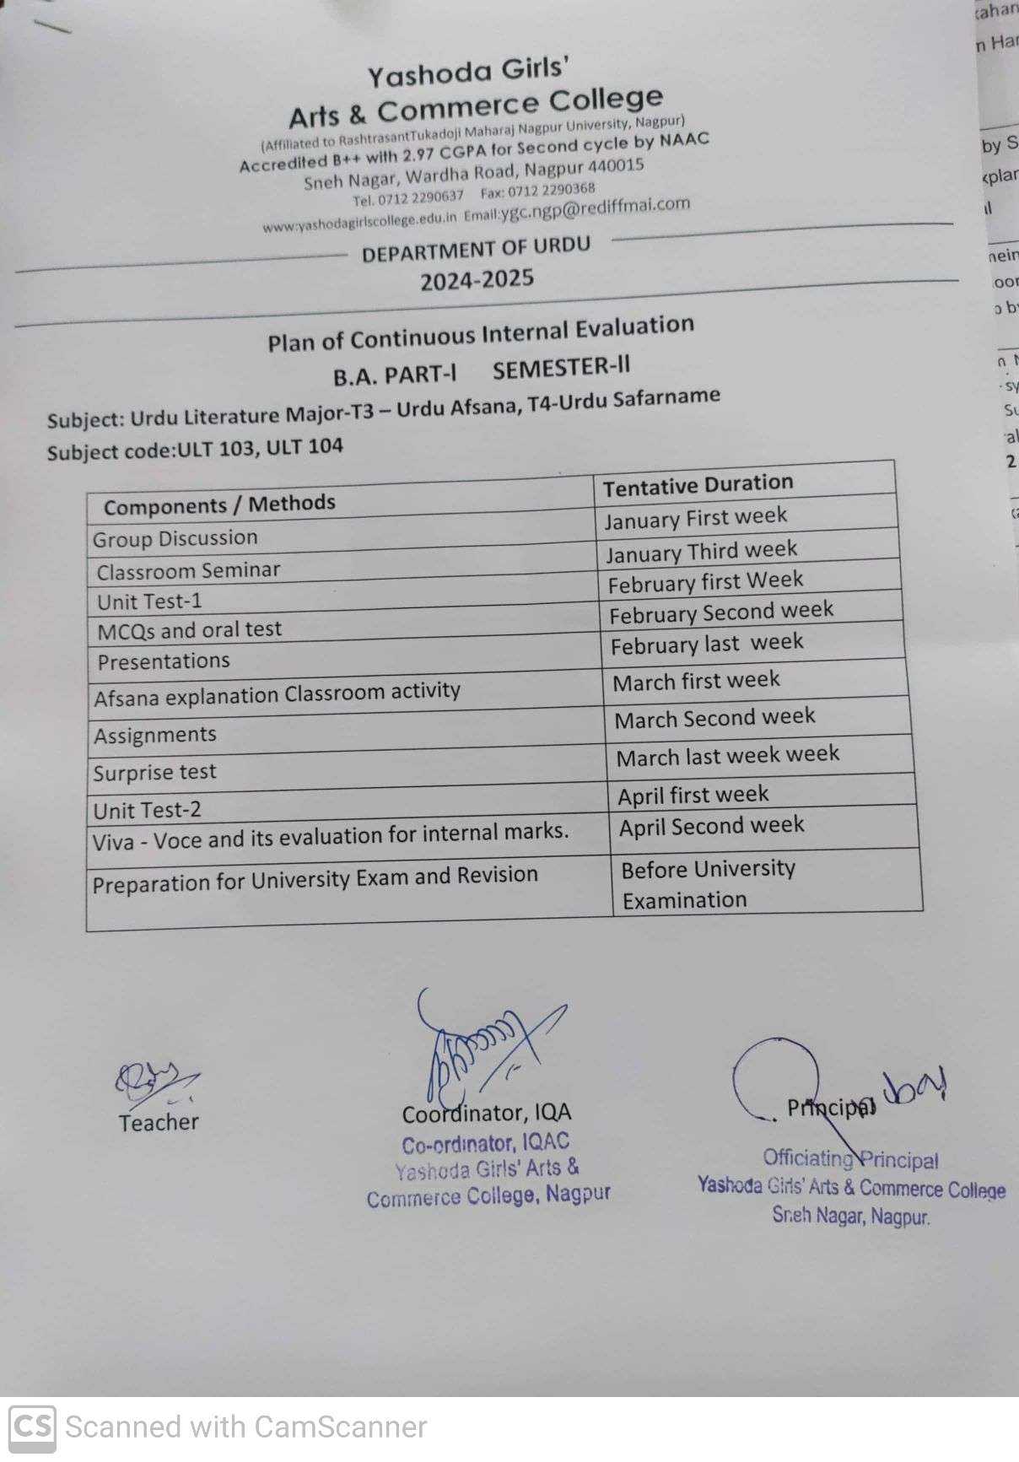

**BA PART-l Semester-ll**

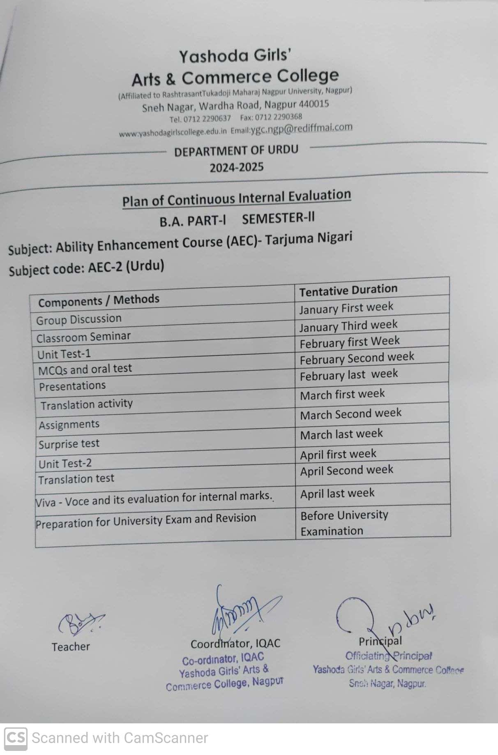

**BA PART-l Semester-ll**

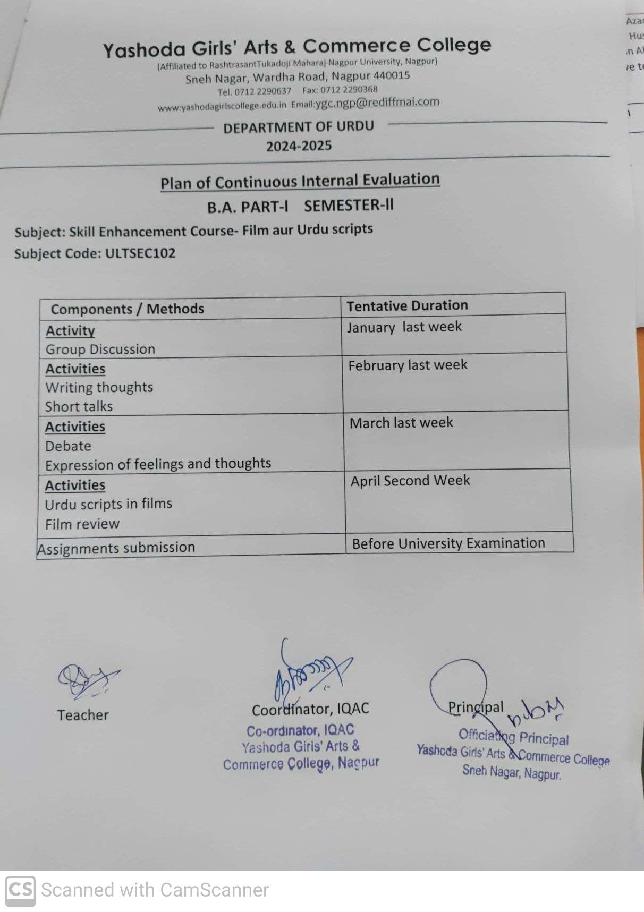

**BA PART-l Semester-ll**

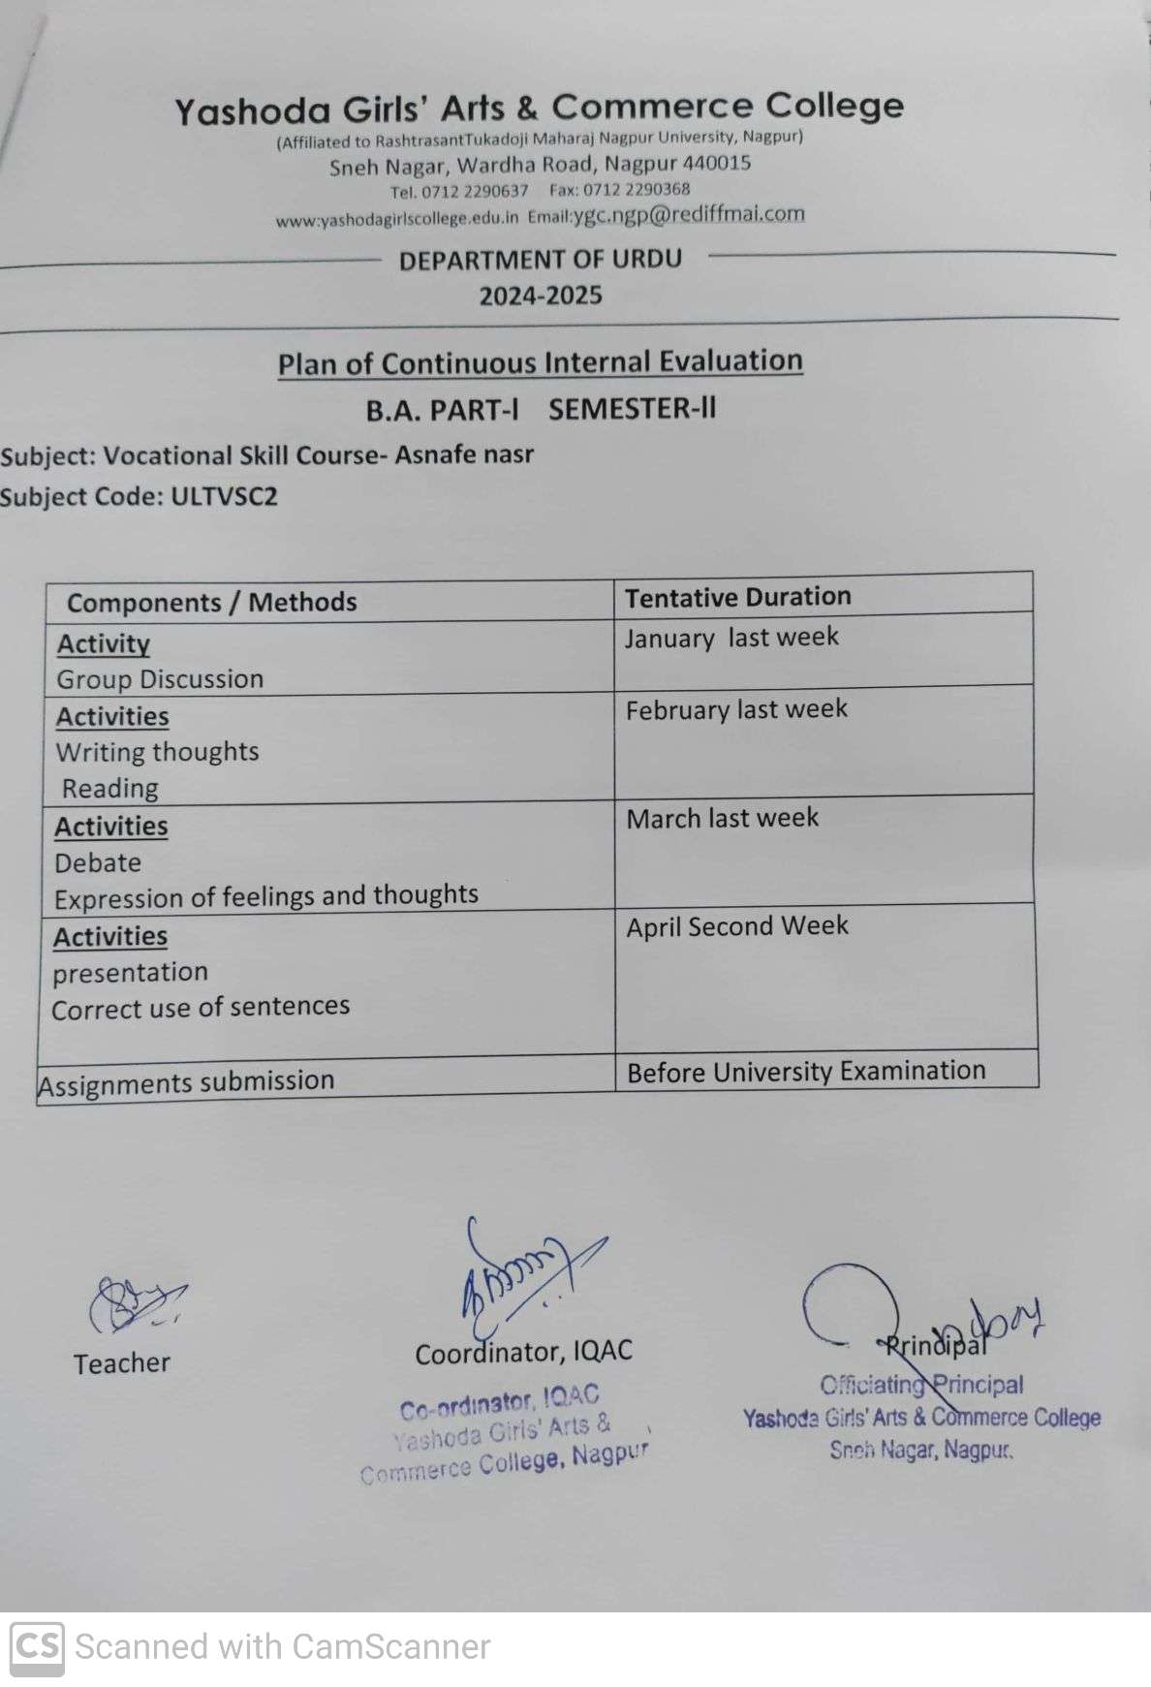

**BA PART-ll Semester-lV**

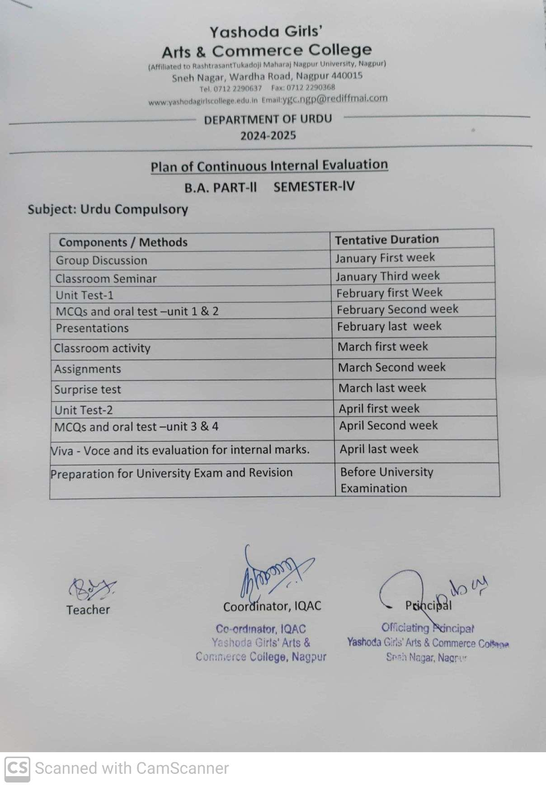

**BA PART-ll Semester-lV**

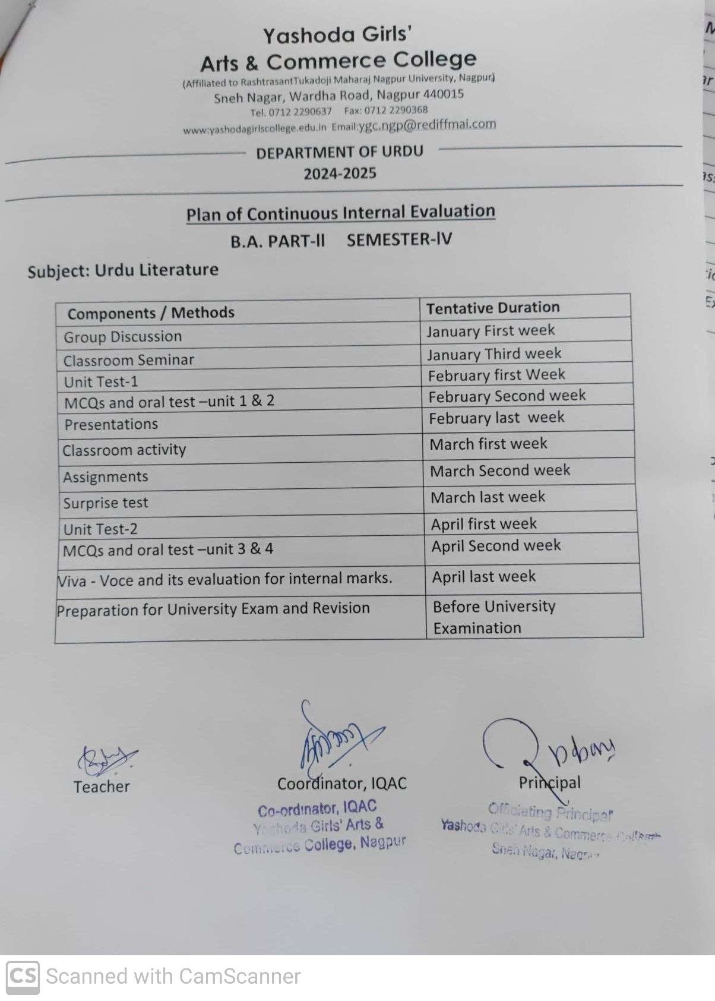

**BA PART-lll Semester-Vl**

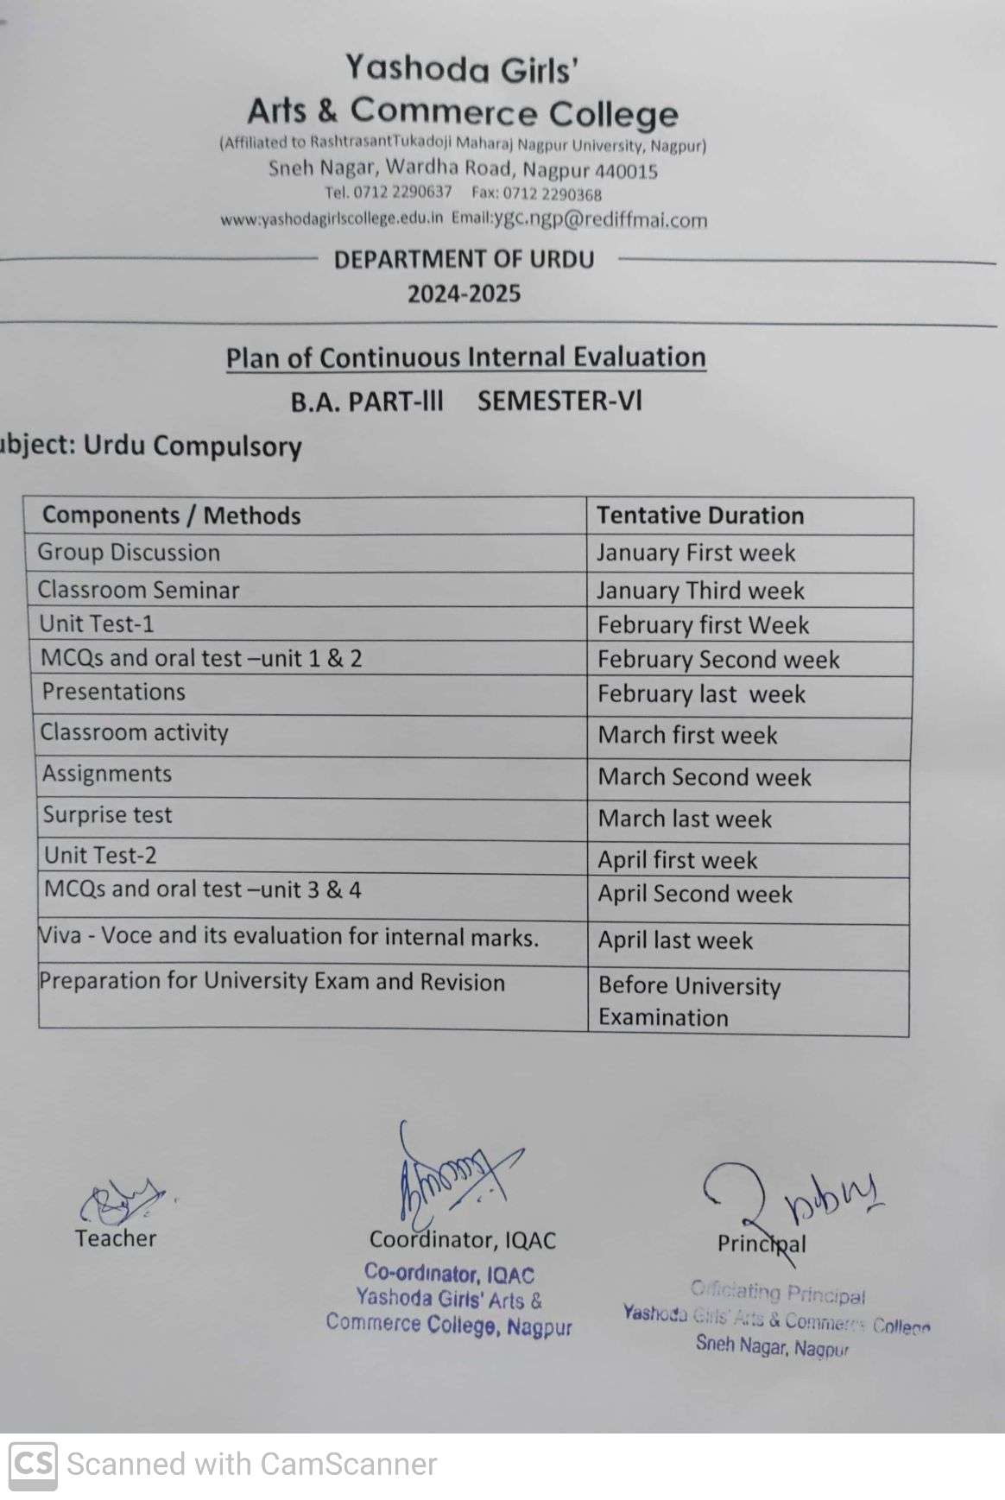

**BA PART-lll Semester-Vl**

