**Yashoda Girls’ Arts & Commerce College, Nagpur**

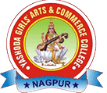

**Department of Sociology**

**Syllabus Link B.A.I ,II & III Odd & Even Sem**

**Session: 2024-2025**

1.B.A.I Sociology

<https://nagpuruniversity.ac.in/pdf/BachelorofArts(Sociology)Syllabus.pdf>

2.B.A.II &III Sociology

<https://nagpuruniversity.ac.in/writereaddata/fckimagefile/BA%20in%20Sociology-3rd%20to%206th%20Sem.pdf>