**Yashoda Girls’ Arts & Commerce College, Nagpur**

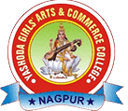

**Department of English**

**CIE – Plan of Continuous Evaluation**

**Academic Session: 2024 -2025**

